**A PROJECT REPORT ON**

**CONTROLLING COMPUTER USING HAND GESTURES**

SUBMITTED TO MIT SCHOOL OF ENGINEERING, LONI, PUNE IN PARTIAL FULFILLMENT OF THE REQUIREMENTS FOR THE AWARD OF THE DEGREE

**BACHELOR OF TECHNOLOGY**

**(Computer Science & Engineering)**

**BY**

Candidate Name: PRN/ Enrollment No:

Pradnya Rohidas Kedari MITU18BTCS0121

Shubhangi Jagdish Kadam MITU18BTCS0102

**Under the guidance of**

RAJESH PRASAD



**DEPARTMENT OF COMPUTER SCIENCE AND ENGINEERING**

**MIT School of Engineering**

**MIT Art, Design and Technology University**

**Rajbaug Campus, Loni-Kalbhor, Pune 412201**

**2021-22**



**MIT SCHOOL OF ENGINEERING**

**DEPARTMENT OF COMPUTER SCIENCE AND ENGINEERING**

**MIT ART, DESIGN AND TECHNOLOGY UNIVERSITY,**

**RAJBAUG CAMPUS, LONI-KALBHOR, PUNE 412201**

**CERTIFICATE**

This is to certify that the dissertation report entitled **“CONTROLLING COMPUTER USING HAND GESTURES”.**

Submitted by: Name of the Candidate PRN/ Enrollment No

**Pradnya Rohidas Kedari MITU18BTCS0121**

**Shubhangi Jagdish Kadam MITU18BTCS0102**

is a bonafide work carried out by them under the supervision of Rajesh Prasad and it is submitted towards the partial fulfillment of the requirement of MIT Art, Design, and Technology University, Pune for the award of the degree of Bachelor of Technology (Computer Science and Engineering).

**Rajesh Prasad Dr. Shraddha Phansalkar**

Guide Head of the Department

Dept. of Computer Sc. & Engg. Dept. of Computer Sc. & Engg.

**Dr. Kishore Ravande**

Principal

MIT School of Engineering,

MIT Art, Design and Technology,

Rajbaug Campus, Loni Kalbhor, Pune 412201

Seal/Stamp of the College

Place: Loni Kalbhor, Pune

Date: 01/07/2022

**DECLARATION**

We, the team members, Ms. Pradnya Rohidas Kedari (MITU18BTCS0121) and Ms. Shubhangi Jagdish Kadam (MITU18BTCS0102) hereby declare that the project work incorporated in the present project entitled “**Controlling Computer using Hand Gestures**” is original work. This work (in part or in full) has not been submitted to any University for the award or a Degree or a Diploma. We have properly acknowledged the material collected from secondary sources wherever required. We solely own the responsibility for the originality of the entire content.

Date: 01/07/2022

Pradnya Rohidas Kedari

Shubhangi Jagdish Kadam

**Name and Signature of Guide**

Rajesh Prasad

Seal/Stamp of the College

Place: Loni Kalbhor, Pune

Date: 01/07/2022



DEPARTMENT OF COMPUTER SCIENCE AND ENGINEERING

MIT SCHOOL OF ENGINEERING,

RAJBAUG CAMPUS, LONI-KALBHOR,

PUNE – 412201

**EXAMINER’S APPROVAL CERTIFICATE**

The project report entitled “CONTROLLING COMPUTER USING HAND GESTURES” is submitted by Ms. Pradnya Rohidas Kedari (MITU18BTCS0121), and Ms. Shubhangi Jagdish Kadam (MITU18BTCS0102) in partial fulfillment for the award of the degree of Bachelor of Technology (Computer Science & Engineering) during the academic year 2021-22, of MIT-ADT University, MIT School of Engineering, Pune, is hereby approved.

**Examiners:**

**1.**

**2.**

**ACKNOWLEDGEMENT**

We would like to express our special thanks and gratitude to our guide Rajesh Prasad sir who gave us guidance and support till the completion of our project work by providing all the necessary information to complete this project.

We would also like to extend our gratitude to our HOD Dr. Shraddha Phansalkar ma’am, Dean of Engineering Dr. Rajneeshkaur Sachdeo ma’am, and our Principal Dr. Kishore Ravande Sir for providing us with support and facility that was required.

We are thankful and fortunate enough to get constant encouragement, support and guidance from our guide as well as from project coordinators of the Department of Computer Science & Engineering, which helped us in successfully completing our project work.

By doing this project we have gained a lot of knowledge which can help us in the near future and also this entire project helped us in doing a lot of Research and we came to know about so many new things we are really thankful to them.

Pradnya Rohidas Kedari

Shubhangi Jagdish Kadam

**ABSTRACT**

The presence on market of the low-cost webcams with, at least, satisfactory qualities open up new directions regarding the implementation of human computer interaction (HCI) interfaces. Gesture is one of the most vivid and dramatic way of communications between human and computer. Hence, there has been a growing interest to create easy-to-use interfaces by directly utilizing the natural communication and management skills of humans.

Hand gesture recognition system contains a decent surveillance present days thanks to simple and straightforward intercommunication between human and machine. The main target of developing hand gesture is to make a much better conveyance between human and computer for delivering information. Hand gestures are a kind of nonverbal way to interact that may be employed in several fields. Research and survey papers supported hand gestures have acquire so many alternative techniques, including those supported on sensor technology and computer vision.

In this project, we decided to design a real-time human-computer interaction system based on hand gesture. Specifically, we will use the convolutional neural network (CNN) in complete process. This application presents a hand gesture interface for controlling a computer that is performing different operations using neural network. The proposed system recognizes a set of specific hand gestures. Our application is based on five phases, Image frame acquisition, Hand tracking, Features extraction, Recognition of gestures and Classification (perform desired operation). A frame from the webcam camera is captured, and then hand detection, hand shape features extraction, and hand gesture recognition will be done.

In this project, we decided to develop a generic Deep Neural Network-Based model for controlling a computer using hand gestures recognition. We will build a system to handle a device using hand gestures.

Our objective is to build and train a model for feature extraction and classification of hand gestures, to use a trained model for classification of hand gestures and recognizing an action and perform an operation accordingly, and to control a computer and perform related activities using hand gestures with the help of computer vision and deep learning algorithm.

**CONTENTS**

Certificate ………………....………………………….…………………………… 2

Declaration ……………….…………….………………....………………………. 3

Examiner’s Approval Certificate …………………………………………………. 4

Acknowledgement ……………….…………………..…………………………… 5

Abstract …………………………………………..…...…………………………... 6

List of Figures ………………………..………….……………………………....... 8

1. INTRODUCTION ............................................................................................... 9

1.1 Introduction ....................................................................................................... 9

1.2 Market Survey ................................................................................................... 10

1.3 Research Gap .................................................................................................... 10

1.4 Problem Statement ............................................................................................ 10

1.5 Objectives ......................................................................................................... 11

2. CONCEPTS AND METHODS........................................................................... 12

2.1 Concepts ............................................................................................................ 12

2.2 Some Basic Terminologies……........................................................................ 13

2.3 Platform/Technology Used …………………………………………………... 13

3. LITERATURE SURVEY.................................................................................... 14

4. PROJECT PLAN................................................................................................. 18

5. IMPLEMENTATION …………………………………………………………. 20

5.1 Dataset ………….............................................................................................. 20

* 1. Implementation ……………………………..................................................... 20

5.2.1 Training of Face Emotion Detector Model ………………………………… 20

5.2.2 Recognition of The Hand Gesture …………………………………………. 23

6. RESULT ............................................................................................................. 24

7. CONCLUSION AND FUTURE WORK............................................................ 29

BIBLIOGRAPHY .................................................................................................. 31

ANNEXURE A: List of Publications and Research Paper

(In its Original formats) ………………………………………………………… 32

ANNEXURE B: Plagiarism Report ....................................................................... 33

**LIST OF FIGURES**

Figure Number: Figure of the table Page Number

Figure 1.1.1 Methodology of Proposed System 10

Figure 4.1 SDLC Agile Model 18

Figure 5.1.1 Dataset Images 20

Figure 5.2.1 CNN Architecture 21

Figure 5.2.1.3 Workflow of Proposed System 23

Figure 6.1 Train vs Val accuracy 24

Figure 6.2 Train vs Val loss 24

Figure 6.3 Overall Result of Model 24

Figure 6.4 Confusion Matrix 24

Figure 6.5 GUI of System 24

Figure 6.6 Gesture Detection Frame 25

Figure 6.7 Opening the WhatsApp 26

Figure 6.8 Opening the Google Chrome 26

Figure 6.9 Opening the PowerPoint Presentation 27

Figure 6.10 Opening the VLC 27

Figure 6.11 Opening the Microsoft Edge 28

1. **INTRODUCTION**
   1. **INTRODUCTION**

Gesture recognition is a full of life analysis field in Human Computer Interaction technology. It has several employments in virtual environment management, medical applications, sign language translation, robot control, music creation, or home automation. During this project Controlling Computer using Hand Gestures, we are going to make a real-time application using OpenCV and Python. OpenCV is a real-time open-source computer vision and image-processing library. We’ll use it via the OpenCV python package.

There has been a special significance recently on Human Computer Interaction (HCI) study to form convenient interfaces by directly using common communication and handling expertise of humans. Among different chassis parts, the hand is the most helpful interaction tool, because of its adroitness. The word gesture is employed for several different cases involving human motion particularly of the hands, arms, and face, only some of these are co-operative or informative.

Gesture recognition is a crucial field that specify human gesture using computer vision techniques and algorithms. There are numerous bodily motion which may develop gesture however the usual type of gesture generation arises from the face and hands. The complete policy of tracing gesture to their representation and changing them to some useful command is called as gesture recognition. Various technologies has been used for the design and implementation of such kind of application.

The CNN or convolutional neural networks are the extremely popular used technique for image classification domain. An image classifier takes an image, or sequence of images that is video as an input and classifies it into one of the possible categories or classes that it was trained to recognize. They have applications in several different fields like driver less cars, defense, education, medical field, fraud detection, etc. There are many algorithms for image classification and also there are some challenges like data overfitting, environment like background color, structure, etc.

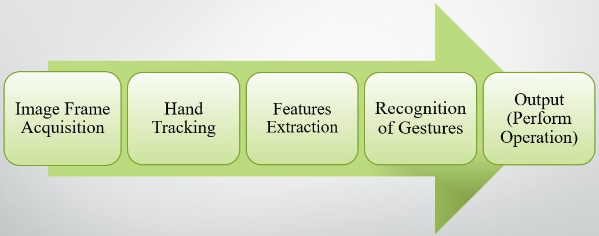

**Figure 1.1.1 Methodology of Proposed System**

* 1. **MARKET SURVEY**

The gesture recognition system has emerged as a popular technology over traditional mechanical interaction technologies. The market is segmented on the basis of Type, Application, Technology, Product and geography. Assistive robotics, Sign language detection, Immersive gaming technology, smart TV, virtual controllers, Virtual mouse, etc.

* 1. **RESEARCH GAP**
* Most of the methods used Arduino and sensors, so it is costly, directly device webcam is used in very few methods.
* There might be miss-recognitions in case the background has elements that resemble the human skin.
* Hand should be within the range limit.
* Dataset overfitting is the main concern.
  1. **PROBLEM STATEMENT**

The aim of this project is to develop an interface to enable users to control other their computers by using hand gestures and a webcam.Hence our problem statement becomes, **“**Controlling Computer using Hand Gestures.”

* 1. **OBJECTIVES**
* To build and train a model for feature extraction and classification of hand gestures.
* To use a trained model for classification of hand gestures and recognizing an action and perform an operation accordingly.
* To control a computer and perform related activities using hand gestures.

1. **CONCEPTS AND METHODS**
   1. **CONCEPTS**

Python is an interpreted, high-level and general-purpose programming language. Its language constructs and object-oriented approach aim to help programmers write clear, logical code for small and large-scale projects. Python is often described as a "batteries included" language due to its comprehensive standard library.

Numpy, pandas, Keras, Sklearn, Matplotlib are the open source libraries used in python programming language, used to perform different operations like Numpy is used for handling arrays and matrix operations, Keras is a deep learning API written in Python, running on top of the machine learning library Tensorflow, Keras uses Tensorflow for its backend, Sklearn (Scikit-learn formerly scikits.learn and also known as sklearn) is a free software library features different machine learning algorithms and Matplotlib is a plotting library for python and numerical mathematics extension Numpy.

Imutils are a series of convenience functions to make basic image processing functions such as translation, rotation, resizing, and displaying Matplotlib images easier with OpenCV and Python.

We used OpenCV library (Open-Source Computer Vision Library) which is an open-source computer vision and machine learning software library. OpenCV is a library of programming functions mainly aimed at real-time computer vision. In simple language it is library used for Image Processing. It is mainly used to do all the operation related to Images.

PyAutoGUI is essentially a Python package that works across Windows, MacOS X and Linux which provides the ability to simulate mouse cursor moves and clicks as well as keyboard button presses. Used to programmatically control the mouse and keyboard.

MediaPipe is an open source machine learning platform used for building complex and multi-model applied machine learning pipelines. It can be used to make cutting-edge machine learning models like face detection, multi-hand tracking, object detection, and tracking and many more.

* 1. **SOME BASIC TERMINOLOGIES**

Artificial Intelligence (AI) - as name suggest can be interpreted to mean incorporating human intelligence to machines. AI is intelligence demonstrated by machines, in contrast to the natural intelligence displayed by humans and animals.

Machine Learning (ML) - ML is the study of computer algorithms that improve automatically through experience. It is seen as a subset of artificial intelligence. Machine learning algorithms a build mathematical model in order to make predictions or decisions without being explicitly programmed to do so.

Deep Learning (DL) - Deep learning (also known as deep structured learning) is part of a broader family of machine learning methods based on artificial neural networks.

Computer Vision - Computer vision is the field that deals with how computers can gain high-level understanding from digital images or videos. From the perspective of engineering, it seeks to understand and automate tasks that the human visual system can do.

Image Processing - Image processing is a method to perform some important operations on an image. In order to get an enhanced high Quality image or to extract the most useful information from that.

Convolutional Neural Network (CNN) - In deep learning, a convolutional neural network is a class of deep neural networks, most commonly applied to analyzing visual imagery. A Convolutional neural network (CNN) is a neural network that has one or more convolutional layers and are used mainly for image processing, classification, etc. CNNs are used for image classification and recognition because of its high accuracy.

* 1. **PLATFORM/TECHNOLOGY USED**
* We developed this project in Python using Jupyter Notebook & Google Colab platform.
* Python (Tensorflow and Keras, Sklearn, Numpy, Pandas)
* OpenCV
* Deep Learning Algorithms

1. **Literature Survey**

In computer science and language technology, gesture recognition is an important topic which interpret human gesture through computer vision algorithms. The entire procedure of tracking gesture to their representation and converting them to some purposeful command is known as gesture recognition. Research and survey papers supported hand gestures have acquire so many alternative techniques, including those supported on sensor technology and computer vision.

The initial approach of communication with computer employing hand gesture was first projected by Myron W. Krueger in 1970 [1]. The purpose of the approach was attained and also the mouse cursor control was accomplished using an external webcam (Genius FaceCam 320), a software package that would paraphrase hand gestures and so turned the acknowledged gestures into OS commands that handled the mouse operations on the display screen of the computer [2]. Selecting hand gesture as an interface in HCI will permit the implementation of a good vary of applications with none physical contact with the computing environments [3]. Nowadays, majority of the HCI relies on devices like keyboard, or mouse, however an enlarging significance in a category of techniques based on computer vision has been came out because of skill to acknowledge human gestures in a habitual manner [4].

The primary aim of gesture recognition is to spot a specific human gesture and carry information to the computer. General objective is to create the computer acknowledged human gestures, to manage remotely with hand poses a good sort of devices [5]. The automated vision-based recognition of hand gesture for management of tools, such as digital TV, play stations and for sign language was take into account as a significant exploration topic lately. However the common issues of those works arise because of several problems, like the complicated and disturbing environments, tone color of skin and also the kind of static and dynamic hand gestures. Hand gestures recognition for TV management is suggested by [6]. During this system, just one gesture is employed to regulate TV by operating user hand. On the display, a hand icon seems that follows the hand of user.

In this paper [7], the actual HCI system that based on gestures and accept gestures uniquely operating one monocular camera and reach out the system to the HRI case has been evolved. The came out system depends on a Convolution Neural Network classifier to grasp features and to acknowledge gestures. The Hidden Markov Model delivers as a crucial tool for the recognition of dynamic gestures in real time. The method employed HMM, works in actual and is built to operate in static environments. The approach is to make the use of LRB topology of HMM in association with the Baum Welch Algorithm for training and also the Forward and Viterbi Algorithms for testing and checking the input finding sequences and producing the most effective attainable state sequence for pattern recognition [8].

In this paper [9], the system is designed even it appears to be easy to use as compared to latest system or command based system however it is less powerful in spotting and recognition. Require to upgrade the system and attempt to construct further strong algorithm for both detection and recognition despite of the confused background environment and a usual lighting environment. Also require to upgrade the system for several additional categories of gestures as system is built for just six classes. However this system can use to manage applications like power point presentation, games, media player, windows picture manager etc. In this paper [10], hand gesture laptop makes the use of an Arduino Uno, Ultrasonic sensors and a laptop to perform the activities like controlling media, playback and volume. Arduino, Ultrasonic sensors, Python used for serial connection. This type of technology can be employed in the classroom for easier and interactive learning, immersive gaming, interacting with virtual objects on screen.

Arduino UNO and ultrasonic sensors based hand gesture to control a computer where they can play pause videos and scroll up and down pages [11]. This paper [12] suggest an efficient ultrasonic based hand gesture monitoring system which is designed with the help of Arduino microcontroller ATMEGA32. The hand gestures recognized effectively with ultrasonic sensors. It is proved that no extra hardware is needed to identify hand gestures and proved that simple inexpensive ultrasonic sensors can be employed to find several ranges to identify hand gestures. In this paper [13], Arduino UNO ARDUINO and python programming with wired ultrasonic sensor based hand gesture system to control a computer where they can zoom in/out and rotate the image is developed. This is successful trial of working of hand motion sensing system using sensors i.e. ultrasonic sensors and finger contact sensors and using in it to Arduino kits in wireless mode using radio frequency.

HCI for MS office and media player and have their own dataset, used skin colored based technique [14]. Application that switch in a Web browser, Web page scrolling, Task switching, Changing the slides of the presentation, Play/pause the video, Video forward and rewind is implemented. Arduino, PySerial, PyautoGUI, etc. used [15]. This project is built in order to make smart home appliance system. Two deep CNN architectures are evolved in this system which are revised from AlexNet and VGGNet, respectively [16]. Done the implementation of the system using Convolutional Neural Network and Back Propagation methodologies. They built a gesture controlling and hand recognition system for the one who are disables [17].

In this paper they have used the surface electromyography (sEMG) sensors with wearable hand gesture devices and mostly applied classifier is Artificial Neural network for sign language hand gesture. In this authors faced overfitting problem in the dataset [18]. The vision based real-time system with Python programming language and OpenCV libraries and Linux framework was implemented. A realtime human gesture recognition using an automated technology called Computer Vision is demonstrated using Linux operating system and Lenet is a CNN architecture used for training of the gestures [19]. This approach is relied on image comparison and motion recognition mechanism to try to do mouse indicator activities and make choice of the icon.

A Virtual gesture control mouse is an approach is developed to help the cursor of the mouse and perform its operations with the help of real-time camera. This method is also built on the basis of image comparison and motion recognition mechanism to try to do mouse indicator operations and choice of icons [20]. Developed a system that assists user friendly interaction such as full-body game and system generating a three-dimensional environment. It is an exploratory study on the gesture selection for operations and also settled an information recapture system to addressseveral doubt phase of users [21].

Hyperparameter of CNN structures which are relied on Alex Net model, are advanced by heuristic optimization algorithms. This suggested approach is tried out on gestures language digits and at the same time Thomas Moeslund’s gesture detection datasets. In this paper they achieved the 94.2% accuracy. Simultaneously, for Thomas Moeslund’s gesture recognition dataset, the established method got 98.09% average accuracy performance and 94.33% average recognition performance [22]. In this paper, they have built an algorithm for real-time hand gesture recognition using convolutional Neural Network (CNN) and they got an average accuracy of 98.76% on the dataset that they have proposed. Dataset consists of total nine hand gestures and 500 image samples for each gesture [23].

A wireless hand gestured controlled fan system is formed. Gyro sensor is employed so as to work out the modification in co-ordinates of the hand. Also used a microcontroller and particularly an Arduino in which coded functions have been run. Hand gesture detection achieved with testing accuracy of 98.61% [24]. To build the gesture detection system and also to minimize the unnecessary information of EMG signals and optimize the dimension of the signal, the Principal Component Analysis (PCA) and GRNN neural network are employed. In this system they have taken total nine static gestures as input observations and made the use of electromyography instrument to examine the characteristics of the signal. The all in all recognition accuracy of the system came to 95.1% [25].

1. **PROJECT PLAN**

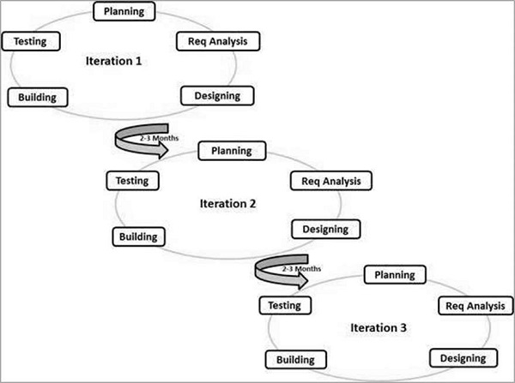

**Figure 4.1 SDLC Agile Model**

Agile SDLC model is a combination of iterative and incremental process models with focus on process adaptability and customer satisfaction by rapid delivery of working software product. Agile Methods break the product into small incremental builds. These builds are provided in iterations. Each iteration typically lasts from about one to three weeks. Every iteration involves cross functional teams working simultaneously on various areas like −

* Planning
* Requirements Analysis
* Design
* Building (Coding)
* Testing
* Deployment and Maintenance

At the end of the iteration, a working product is displayed to the customer and important stakeholders.

1. **IMPLEMENTATION**
   1. **DATASET**

We tried to use available dataset, but we faced overfitting problem. Thus we create our own dataset for training the model. We took total 10 different hand gestures to perform activities like opening the WhatsApp, PowerPoint presentation, Microsoft Edge, Google Chrome, Video Player, etc. We took total 3000 images for training, 2000 images for testing and 500 images for validation.

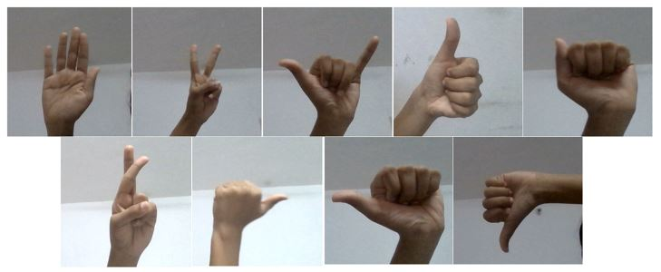

**Figure 5.1.1 Dataset Images**

* 1. **IMPLEMENTATION**
     1. Train The Hand Gesture Recognizer Model

In this module first upon we will have a look on the dataset. We have total 3000 images for training, 2000 images for testing and 500 images for validation. We have performed image data augmentation, as someone said “Keras ImageDataGenerator is a gem!” it lets us augment our images in real-time while the model is still training! We can apply any random transformations on each image from dataset as it is passed to the model. This will not only make our model robust but will also save up on the overhead memory!

Now our next task is to train our hand gesture detector model. For that we have used Convolution Neural Network (CNN) architecture revised from VGGNet. CNN are used as black-boxes and their learned features remain hidden.

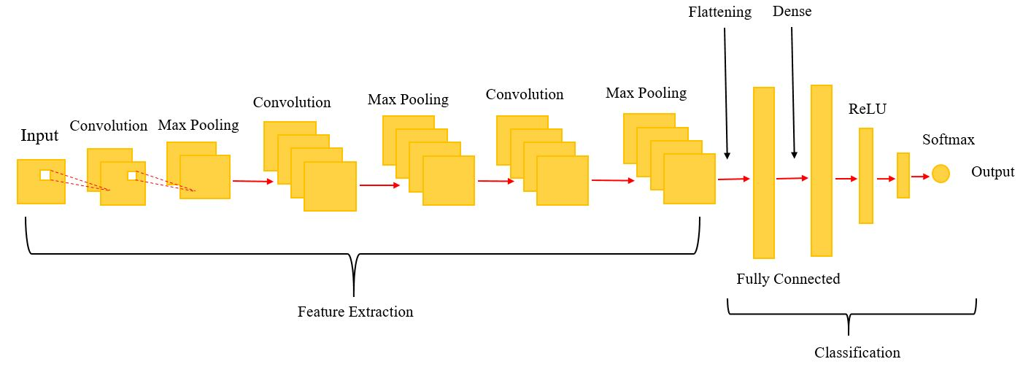

**Figure 5.2.1.1 CNN Architecture**

In this, for creating the model, we have used VGG19 (inception learning). VGG is a successor of AlexNet. VGG19 is a deep convolution neural network having convolution layer, pooling layer (max pool), fully connected layer, ReLU and softmax in its architecture. The first building block in our plan of attack is convolution operation. In this step, we will touch on feature detectors, which basically serve as the neural network's filters. We will also discuss feature maps, learning the parameters of such maps, how patterns are detected, the layers of detection, and how the findings are mapped out. The second step is pooling, pooling layers are used to reduce the dimensions of the feature maps. Thus, it reduces the number of parameters to learn and the amount of computation performed in the network. The pooling layer summarizes the features present in a region of the feature map generated by a convolution layer, however, will be a specific type of pooling; max pooling. Max pooling is a pooling operation that selects the maximum element from the region of the feature map covered by the filter. Thus, the output after max-pooling layer would be a feature map containing the most prominent features of the previous feature map. The third step will involve flattening, this will be a brief breakdown of the flattening process and how we move from pooled to flattened layers when working with Convolutional Neural Networks. Flatten is the function that converts the pooled feature map to a single column that is passed to the fully connected layer. Fully Connected layers, in this part, everything that we covered throughout the section will be merged together. Dense adds the fully connected layer to the neural network. The dense layer is a neural network layer that is connected deeply, which means each neuron in the dense layer receives input from all neurons of its previous layer. Thus, they're densely connected. In other words, the dense layer is a fully connected layer, meaning all the neurons in a layer are connected to those in the next layer. Dropout is a technique where randomly selected neurons are ignored during training. They are “dropped-out” randomly. This means that their contribution to the activation of downstream neurons is temporally removed on the forward pass and any weight updates are not applied to the neuron on the backward pass. Rectified Linear Unit or ReLU, the rectified linear activation function or ReLU for short is a piecewise linear function that will output the input directly if it is positive, otherwise, it will output zero. Mathematically, it is defined as y = max (0, x). The softmax function is a function that turns a vector of K real values into a vector of K real values that sum to 1. The input values can be positive, negative, zero, or greater than one, but the softmax transforms them into values between 0 and 1, so that they can be interpreted as probabilities. If one of the inputs is small or negative, the softmax turns it into a small probability, and if an input is large, then it turns it into a large probability, but it will always remain between 0 and 1. For this reason it is usual to append a softmax function as the final layer of the neural network. Softmax is often used as the final layer in the network, for a classification task.

Now after creation of model, we compiled and trained our model. Then after checking the accuracy, visualization of results by plotting graphs, and saving the model we finished with the training module.

Here, process is taking the image of the gesture as an input using the web-cam and then compress the image by using the CNN algorithm to match the images in the dataset in order to detect the hand moment accurately. The captured image is preprocessed and a hand detector tries to filter out the hand image from the captured image. A CNN classifier is employed to recognize gestures from the processed image after feature extraction.

We used Adam optimizer because accuracy rate of this optimizer is much better than others. The whole workflow of our proposed system is explained through following image,

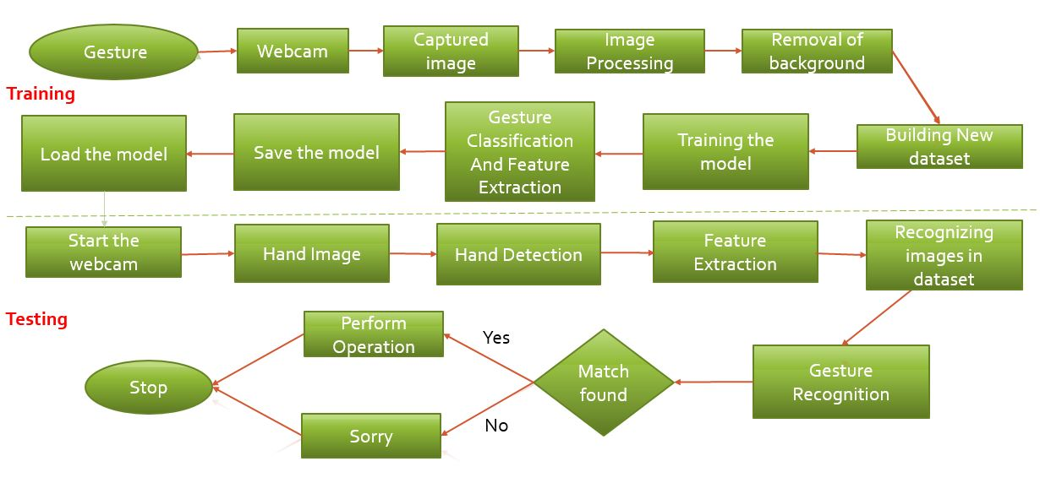

**Figure 5.2.1.3 Workflow of Proposed System**

* + 1. Recognize The Hand Gesture And Perform Actions

Now we have trained model. This model will detect the hand, then features will be extracted and if gesture is recognized then particular operation will be perform. We have also added one more functionality in our implementation that tells user which action is performed. We developed GUI for our application.

Now our defined modules are completed and our trained model is detecting the hand and performing specific actions. Thus, we successfully implemented defined problem statement.

1. **RESULT**

Following are the two plots of train-val accuracy and train-val loss. We got 80.40% validation accuracy.

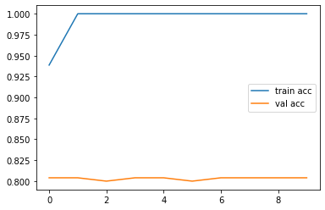 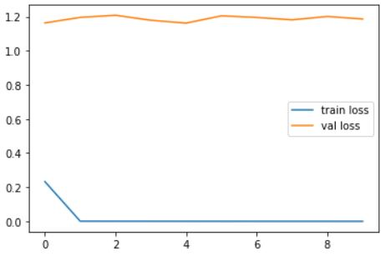 **Figure 6.1 Train vs Val accuracy Figure 6.2 Train vs Val loss**

We achieved following result of evaluation metrics. Our model is confused in some of the gestures like cross, scissor, up, etc. We achieved 85.90% accuracy at the time of testing our model. Following are the classification reports we got.

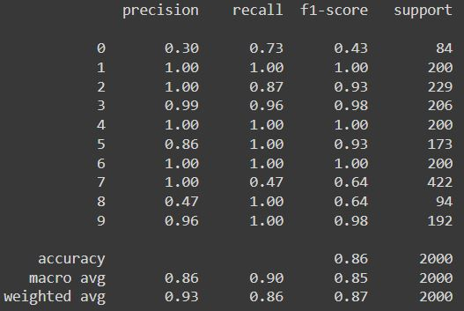 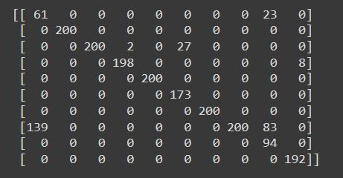

**Figure 6.3 Overall Result of Model Figure 6.4 Confusion Matrix**

Below are the images of GUI of our system,

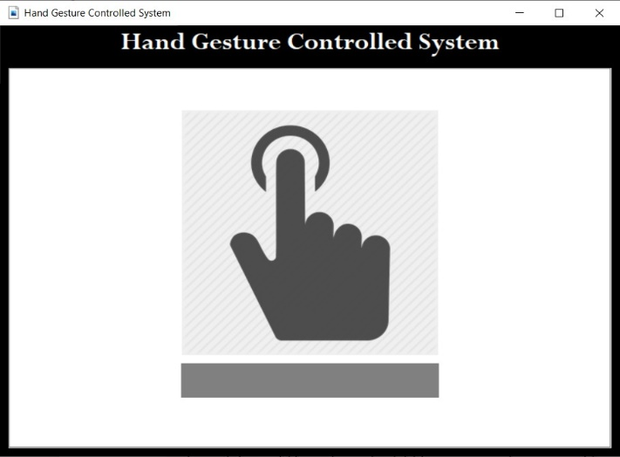 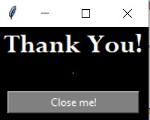

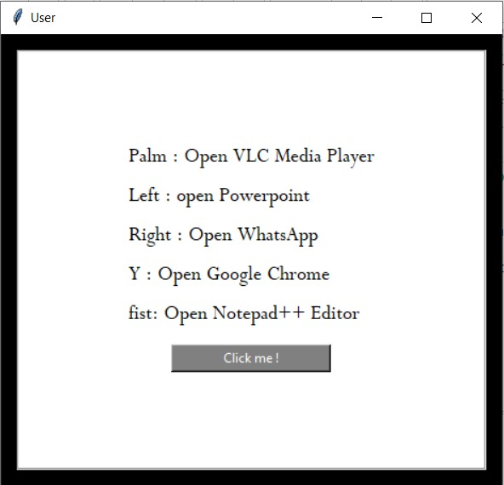

**Figure 6.5 GUI of System**

Below are the some demons of the developed system. We assigned total 10 hand gestures to perform different operations.

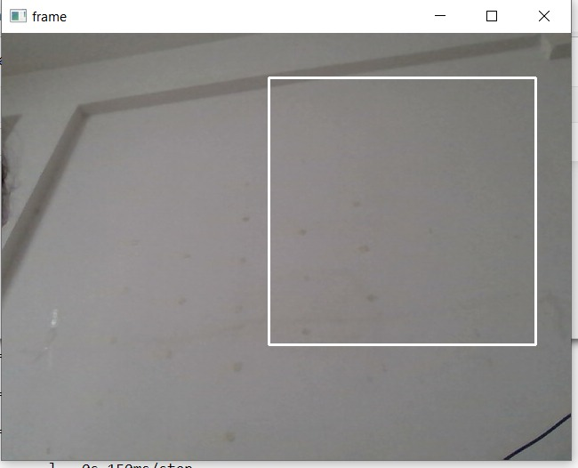

**Figure 6.6 Gesture Detecting Frame**

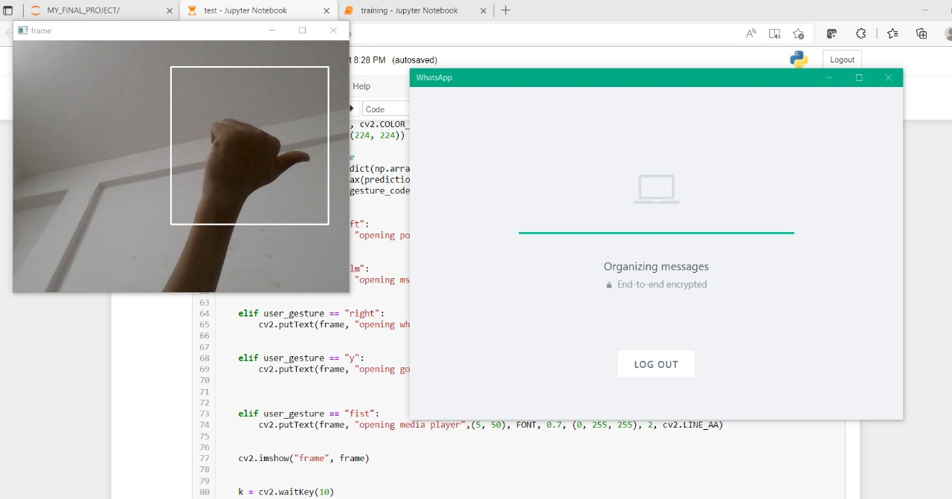

**Figure 6.7 Opening the WhatsApp**

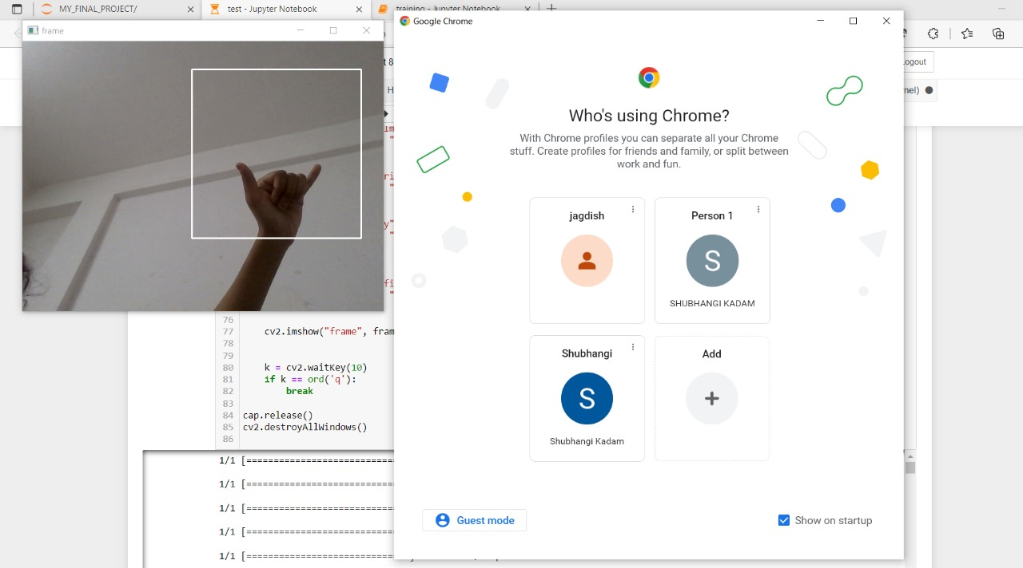

**Figure 6.8 Opening the Google Chrome**

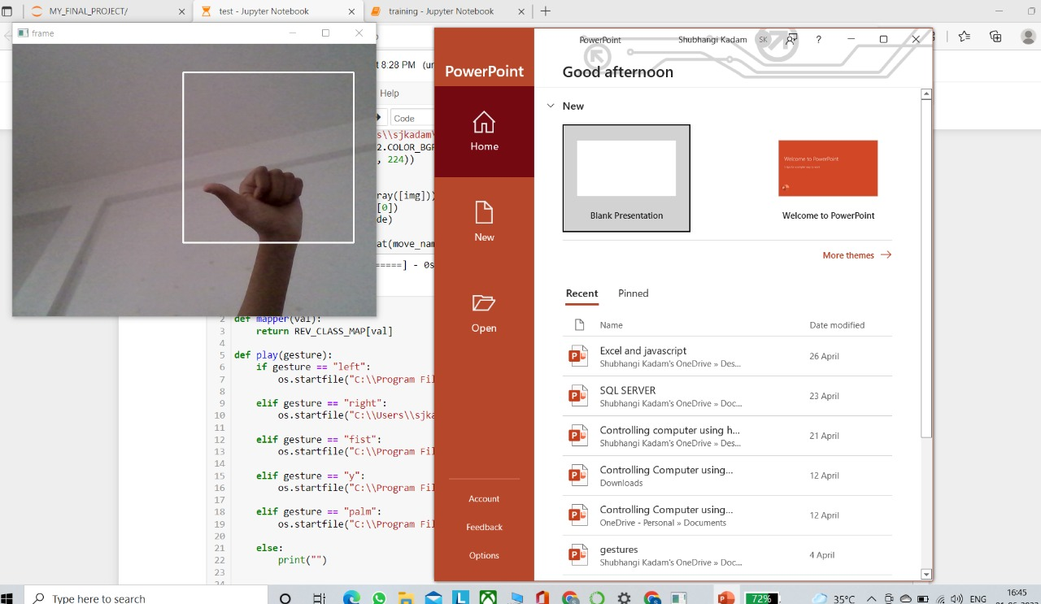

**Figure 6.9 Opening the PowerPoint Presentation**

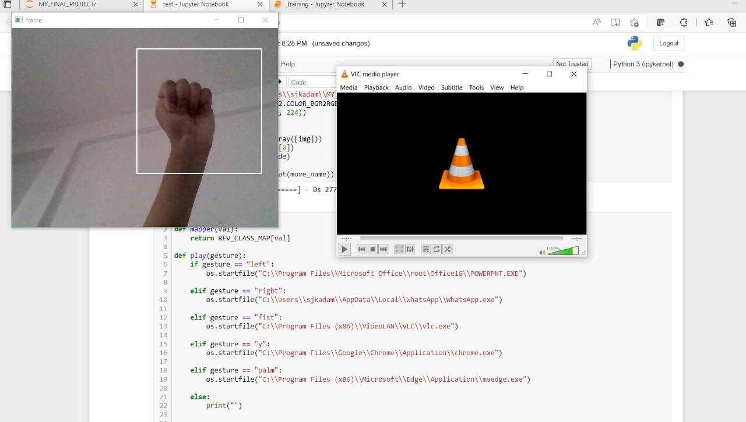

**Figure 6.10 Opening the VLC**

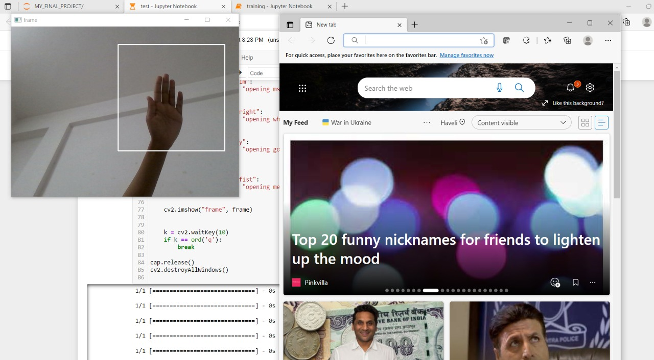

**Figure 6.11 Opening the Microsoft Edge**

1. **CONCLUSION AND FUTURE WORK**

With the growth of present technology, and as humans generally makes the use of hand movements that is hand gestures in the daily communication in order to make intentions more clear, hand gesture identification is treated to be a crucial portion of Human Computer Interaction (HCI), which provides devices the capability of detecting and classifying hand gestures, and perform activities subsequently.

Research and analysis in the field of hand gestures has become more popular and exciting. It also allows a way of natural and simple interaction. Standard interactive techniques based on several tools like a mouse, keyboard/touch pad, or touch screen, joystick for gaming and consoles for system management. In this paper we have discussed the overall review of gesture acquisition methods, the feature extraction process, the classification of hand gestures, the challenges that face researchers in the hand gesture recognition process.

In this application, we developed a deep learning model for controlling a computer using hand gestures with the help of Python and OpenCV. It is the cost effective model. We can define a project as creating a dataset, training a model and testing this model in real time. This project have limited scope, but in future we can add more operations like volume up/down, scroll up/down, swipe left/right and many more, and can possible to make completely hand gestures controlling device.

Hand gesture recognition used in many applications like HCI, robotics, sign language, digit and alphanumeric value, home automation, medical applications, gaming etc. Hand gestures recognition provides an interesting interaction field in a several different computer applications. With the development of today’s technology, and as humans tend to naturally use hand gestures in their communication process to clarify their intentions, hand gesture recognition is considered to be an important part of Human Computer Interaction (HCI), which gives computers the ability of capturing and interpreting hand gestures, and executing commands afterwards.

It was a wonderful and learning experience for our team while working on this project. This journey of project involved various problems and challenges gave us feel of programmers and gained programming knowledge.

**BIBLIOGRAPHY**

1. M. KRUEGER, Artificial reality II, Addison-Wesley Reading (Ma), 1991.
2. Horatiu-Stefan Grif and Cornel Cristian Farcas, "Mouse Cursor Control System Based on Hand Gesture", 9th International Conference Interdisciplinarity in Engineering, INTER-ENG 2015, 8-9 October 2015, Tirgu Mures, Romania.
3. H.A JALAB, "Static hand Gesture recognition for human computer interaction", Asian Network for Scientific Information technology journal, pp. 1-7, 2012.
4. J C.MANRESA, R VARONA, R. MAS and F. PERALES, "Hand tracking and gesture recognition for humancomputer interaction", Electronic letters on computer vision and image analysis, vol. 5, pp. 96-104, 2005.
5. H. HASAN and S. ABDUL-KAREEM, "Static hand gesture recognition using neural networks", Artificial Intelligence Review, vol. 41, pp. 147-181, 2014.
6. W. FREEMAN and C. WEISSMAN, "Television control by hand gestures", Proc. of Intl. Workshop on Automatic Face and Gesture Recognition 1995, pp. 179-183, 1995.
7. Pei Xu, "A Real-time Hand Gesture Recognition and Human-Computer Interaction System", arXiv:1704.07296v1 [cs.CV] 24 Apr 2017.
8. J.R Pansare, Malvika Bansal, Shivin Saxena, Devendra Desale, "Gestuelle: A System to Recognize Dynamic Hand Gestures using Hidden Markov Model to Control Windows Applications", International Journal of Computer Applications (0975 – 8887) Volume 62– No.17, January 2013.
9. Ram Pratap Sharma and Gyanendra K. Verma, "Human Computer Interaction using Hand Gesture", Eleventh International Multi-Conference on Information Processing-2015 (IMCIP-2015).
10. Rohit Mukherjee, Pradeep Swethen, Ruman Pasha, Sachin Singh Rawat, “Hand Gestured Controlled laptop using Arduino”, International Journal of Management, Technology And Engineering, October 2018.
11. Ayushi Bhawal, Debaparna Dasgupta, Arka Ghosh, Koyena Mitra, Surajit Basak, “Arduino Based Hand Gesture Control of Computer”, IJESC, Volume 10, Issue No.6, June 2020. [
12. Udit Kumar, Sanjana Kintali, Kolla Sai Latha, Asraf Ali, N. Suresh Kumar, “Hand Gesture Controlled Laptop Using Arduino”, April 2020.
13. Sarita K., Gavale Yogesh, S. Jadhav, “HAND GESTURE DETECTION USING ARDUINO AND PYTHON FOR SCREEN CONTROL”, International Journal of Engineering Applied Sciences and Technology, 2020, Vol. 5, Issue 3, ISSN No. 2455-2143, July 2020.
14. Ram Pratap sharma, Gyanendra Varma, “Human computer interaction using hand gesture”, 2015.
15. J. S. Vimali, Senduru Srinivasulu, J. Jabez, S. Gowr, “Hand Gesture Recognition Control for Computers Using Arduino”, 2020.
16. Chung, Hung-Yuan, Yao-Liang Chung, and Wei-Feng Tsai. "An efficient hand gesture recognition system based on deep CNN." 2019 IEEE International Conference on Industrial Technology (ICIT). IEEE, 2019.
17. Varun, Kollipara Sai, I. Puneeth, and T. Prem Jacob. "Hand gesture recognition and implementation for disables using CNN’S." 2019 International Conference on Communication and Signal Processing (ICCSP). IEEE, 2019.
18. Yasen, Mais, and Shaidah Jusoh. "A systematic review on hand gesture recognition techniques, challenges and applications." PeerJ Computer Science 5 (2019): e218.
19. Suresh, Malavika, Avigyan Sinha, and R. P. Aneesh. "RealTime Hand Gesture Recognition Using Deep Learning." International Journal of Innovations and Implementations in Engineering 1 (2019).
20. Shibly, Kabid Hassan, et al. "Design and development of hand gesture based virtual mouse." 2019 1st International Conference on Advances in Science, Engineering and Robotics Technology (ICASERT). IEEE, 2019.
21. Wu, Huiyue, et al. "The gesture disagreement problem in free-hand gesture interaction." International Journal of Human–Computer Interaction 35.12 (2019): 1102-1114.
22. Ozcan, Tayyip, and Alper Basturk. "Transfer learningbased convolutional neural networks with heuristic optimization for hand gesture recognition." Neural Computing and Applications 31.12 (2019): 8955-8970.
23. Zhan, Felix. "Hand gesture recognition with convolution neural networks." 2019 IEEE 20th International Conference on Information Reuse and Integration for Data Science (IRI). IEEE, 2019.
24. Alon, Alvin Sarraga, and Julie Ann B. Susa. "Wireless Hand Gesture Recognition for an Automatic Fan Speed Control System: Rule-Based Approach." 2020 16th IEEE International Colloquium on Signal Processing & Its Applications (CSPA). IEEE, 2020.
25. Qi, Jinxian, et al. "Surface EMG hand gesture recognition system based on PCA and GRNN." Neural Computing and Applications 32.10 (2020): 6343-6351.

**ANNEXURE A: List of Publications and Research Paper (In its Original formats)**

1. Publication Name: International Research Journal of Engineering and Technology (IRJET)

Publication site: <https://www.irjet.net/>

Paper Link: <https://www.irjet.net/archives/V9/i2/IRJET-V9I2181.pdf>

Status: **Published**

1. Publication Name: Resbee Publisher Multimedia Research Journal

Publication site: <https://publisher.resbee.org/Journal-publishing-service.php?journal=mr>

Paper Link:

Status: **Submitted**

1. Publication Name: International Research Journal of Engineering and Technology (IRJET)

Publication site: <https://www.irjet.net/>

Paper Link:

Status: **Submitted**

**ANNEXURE B: Plagiarism Report**

Page1of2

domain, fraud detection, defense, etc. There are several techniques and algorithms for image classification task and also

it was trained to classify. They have applications in different fields such as medical domain, self-driving cars, educational

classifier takes an input image, or input sequence of images and categories them into one among the possible classes that

The convolutional neural networks are the most popular employed technique for the image classification task. An image

involving human motion particularly of the hands, arms, and face, just some of these are informative.

helpful communication tool in several body parts, because of its expertise. The word gesture is employed for several cases

creation, or home automation. There has been a special significance recently on HCI study. Hand is the one which is most

employments in virtual environment management, medical applications, sign language translation, robot control, music

Gesture recognition is a popular and in-demand analysis field in Human Computer Interaction technology. It has several

1. INTRODUCTION

Key Words: Deep Learning, Computer Vision, Hand Gestures, Convolutional Neural Network, Python, OpenCV

gesture recognition are done.

operation). An image from the webcam will be captured, and so hand detection, hand shape features extraction, and hand

Image frame acquisition, Hand tracking, Features extraction, Recognition of gestures and Classification (perform desired

control a computer that is performing different operations using neural network. Our application is defined in five phases,

convolutional neural network (CNN) in throughout the process. This application presents a hand gesture-based system to

In this system, we aimed to build a real-time gesture recognition system using hand gestures. Particularly, we will use the

techniques, including those supported on sensor technology and computer vision.

several fields. Research and survey papers included hand gestures applications have acquire different alternative

hand gesture system is very useful. Hand gestures are a sort of nonverbal type to communicate that may be employed in

machine is through gesture. For higher conveyance between the human and machine/computer to convey information,

are inexpensive and can get easily available in the market. The most powerful way for communication between human and

Abstract – Human computer interaction platform have many ways to implement as webcams and other devices like sensors

------

---------------------------------------------------------------------***---------------------------------------------------------------

Technology, Pune, Maharashtra, India

3Professor, Department of Computer Science and Engineering, MIT School of Engineering, MIT Art, Design and

Pune, Maharashtra, India

2Student, Department of Computer Science and Engineering, MIT School of Engineering, MIT Art, Design and Technology,

Pune, Maharashtra, India

1Student, Department of Computer Science and Engineering, MIT School of Engineering, MIT Art, Design and Technology,

Pradnya Kedari1, Shubhangi Kadam2, Rajesh Prasad3

Controlling Computer using Hand Gestures

Content Checked For Plagiarism

Characters

5861

Plagiarised

Unique

Words

834

2%

98%

Date

2022-06-08

PLAGIARISM SCAN REPORT



there are some challenges like data overfitting. During this project Controlling Computer using Hand Gestures, we are

Page2of2

https://www.irjet.net/archives/V9/i2/IRJET-V9I2181.pdf/

interfaces by directly using common communication and handling expertise of humans.

package. There has been a special significance recently on Human Computer Interaction (HCI) study to form convenient

OpenCV is a real-time open-source computer vision and image-processing library. We’ll use it via the OpenCV python

Title:www.irjet.net › archives › V9A Survey Paper on Controlling Computer using Hand Gestures

Similarity 4%

Matched Source

popular because of skill to recognize human gestures in a simple manner [4].

or mouse, however the growing importance in a category of methods and techniques based on computer vision has been

of physical contact with the computing devices [3]. At present, most of the HCI depends on the devices such as keyboard,

hand gesture as a communication tool in HCI will allow the development of a good vary of applications with the absence

gestures into OS commands that controlled the mouse actions on the display screen of the computer device [2]. Choosing

webcam (Genius FaceCam 320), a software package that would interpret hand gestures and then turned the recognized

[1]. The aim of the perspective was achieved and also the mouse cursor control was performed with the help of an external

The starting approach of interaction with computer using hand gesture was first projected by Myron W. Krueger in 1970

Different techniques and methods has been employed for the design and development of such kind of task.

tracking gesture to their representation and changing them to some useful command is refer as gesture recognition.

gestures but the most common type of gesture generation stand up from the face and hands. The complete policy of

using different computer vision techniques and algorithms. There are numerous human body motions which can create

In computer science and technology era, gesture recognition is a crucial field which can use to translate human gesture

2. LITERATURE SURVEY

• Dataset overfitting is the main concern.

• Hand should be within the range limit.

skin.

• There might be miss-recognitions of gestures in case the background environment has elements that appears like human

• Most of the methods used Arduino and sensors, directly device webcam is used in very few methods.

1.2 RESEARCH GAP

mouse, etc.

Geography. Assistive robotics, Sign language detection, Immersive gaming technology, smart TV, virtual controllers, Virtual

popular technology. The domain market is divided on the different basis like Technology, Type, Practice, Product, Use and

Over the traditional mechanical communication technologies, gesture recognition system has become known as a most

1.1 MARKET SURVEY

Fig 1. Methodology of Proposed System

OpenCV python package.

OpenCV is a real-time open-source computer vision and image-processing library. We’ll use it with the help of the

aimed to make a real-time application using OpenCV and Python.



Page1of2

3. IMPLEMENTATION AND WORKING

Hand gesture recognition system for Microsoft Office and media player with their own dataset is developed. [14].

successful trial of working of hand motion sensing system using sensors and Arduino kits in wireless mode radio frequency.

developed to manage a device and they included operations like zoom in/out and image rotation, etc. This trial is

this paper [13], hand gesture system relied on Arduino UNO and python programming with wired ultrasonic sensor is

claimed that simple low cost ultrasonic sensors can be used to notice different range limits to identify hand gestures. In

Arduino microcontroller ATMEGA32. It is claimed that extra hardware is not require to classify hand gestures and also

This paper [12] suggest a convenient hand gesture monitoring system based on ultrasonic sensors, which is built using

where they can control VLC by involving operations like play and pause videos and also for page scroll up and down [11].

Hand Gesture recognition system based on devices like Arduino UNO and several ultrasonic sensors to manage a device

can be used in the teaching classrooms.

Arduino, Ultrasonic sensors, Python used for serial connection. For interactive and effective learning, such type of system

Uno and Ultrasonic sensors, operations such as handling media player, volume increase/decrease are performed on laptop.

such as power point presentation, windows picture manager, media player, games etc. In this paper [10], using an Arduino

for gesture recognition. This system is built for total six classes. However this exist model can be used to control operations

and a normal lighting environment background, exist system need to improve and require to build further a good network

less powerful in spotting the gestures and recognition of the same. So despite of the complex environmental background

to handle as compared to the newest available system or command based system but drawback is developed system is

productive achievable pattern recognition state sequence [8]. In this paper [9], even the developed model seems to be easy

and also for testing, the Forward and Viterbi Algorithms and checking the input sequences and building the maximum

The proposed methodology was for training, to employ the topology named LRB of HMM with the Baum Welch Algorithm

system employed HMM, operate in present and the general aim to build this system is to operate in static environments.

The HMM that is Hidden Markov Model considered as a crucial tool for the dynamic gestures recognition in actual. The

features and to recognize particular hand gesture.

case has been developed. The evolved system relies on a classifier based on Convolution Neural Network to extract

hand gestures and accept gestures in a unique way to operate using monocular camera and assist the system to the HRI

the screen display of TV. In this paper [7], the actual human computer interface that is HCI model which is based on the

hand moment is used to control TV. A hand picture looks like icon that follows the hand movements of the user appear on

problem of that system raised. Hand gestures recognition for management of TV is recommended by [6]. In this, only one

difference, the complex and disturbing environments and also the different static and dynamic hand gestures, the common

sign language was considered as a weighty research area lately. But because of different issues, like skin tone color

on the robotic computer vision to handle the devices such as digital TV, play stations, etc. Hand gesture recognition for

device to control a good sort of devices that are at distant using different hand poses [5]. Hand gesture recognition based

of gesture recognition. Overall objective of this system was to create the human gestures which can be admit by computer

Detection and recognition of a particular human body gesture and carry information to the computer is the main objective

Content Checked For Plagiarism

Characters

5295

Plagiarised

Unique

Words

848

2%

98%

Date

2022-06-08

PLAGIARISM SCAN REPORT



Page2of2

https://github.com/recepayddogdu/Freespace_Segmentation-Ford_Otosan_Intern/blob/main/Questions_and_Answers.md

Title:Freespace_Segmentation-Ford_Otosan_Intern ... - GitHub

Similarity 4%

Matched Source

Fig 1. CNN Architecture

box.

architecture revised from Squeezenet and VGGNet. Learned features of CNN remain hidden and thus it is used as black-

Now our next task is to train our hand gesture detector model. For that we have used Convolution Neural Network (CNN)

will also lay aside on the overhead memory!

transformations on each image from dataset as it is passed to the model. This will not only make our model powerful but

a gem!” it lets us augment our images in real-time while the model is still training. We can apply any random

500 images for validation. We have performed image data augmentation, as somebody said “Keras ImageDataGenerator is

In this module first upon have a glance on the dataset. We have total 3000 images for training, 2000 images for testing and

a. Train The Hand Gesture Recognizer Model

3.2 IMPLEMENTATION

Fig 2. Sample Dataset Images

2000 images for testing and 500 images for validation.

Microsoft Word, Microsoft Edge, Google Chrome, Video Player, Xbox, and Paint etc. We took total 3000 images for training,

We took total 10 different hand gestures to perform activities like opening the WhatsApp, PowerPoint presentation,

We tried to use available dataset, but we faced overfitting problem. Thus we create our own dataset for training the model.

3.1 DATASET



Page1of2

Fig 7.

Overall Result of Model

Fig 8.

Confusion Matrix

etc. We achieved 85.90% accuracy at the time of testing our model. Following are the classification reports we got.

We achieved following result of evaluation metrics. Our model is confused in some of the gestures like cross, scissor, up,

Fig 3. Train vs Val accuracy Fig 6.

Train vs Val accuracy

Following are the two plots of train-val accuracy and train-val loss. We got 80.40% validation accuracy.

4. RESULT AND ANALYSIS

which action is performed.

then particular operation will be perform. We also added one more functionality in our implementation that tells user

Now we have trained model. This model will detect the hand, then features will be extracted and if gesture is recognized

b. Recognize The Hand Gesture and Perform Operations

the processed image after feature extraction.

detector tries to filter out the hand image from the captured image. A CNN classifier is used to recognize gestures from

images in the dataset in order to detect the hand moment accurately. The captured image is preprocessed, and a hand

the hand gesture as an input using the webcam and then compress the image by using the CNN algorithm to match the

by plotting graphs, and saving the model we finished with the training module. Here, complete task is taking the image of

Now after creation of model, we compiled and trained our model. Then after checking the accuracy, visualization of results

Fig 2. Workflow of Proposed System

proposed system is explained through following image Fig 2,

We used Adam optimizer because accuracy rate of this optimizer is much better than others. The whole workflow of our

the final layer in the network, for a classification task.

For this reason it is usual to append a softmax function as the final layer of the neural network. Softmax is often used as

always remain between 0 and 1.

input value into values between 0 and 1, so that they can be interpreted as probabilities. Final output of this layer will

positive, otherwise, it will output zero. Mathematically, it is defined as y = max (0, x). The softmax function transforms

supposed to connect deeply. Rectified Linear Unit or ReLU is a linear function that will output the input directly if it is

will be merged together. Dense adds the fully connected layer to the neural network. In the dense layer neurons are

passed to the fully connected layer. Fully Connected layers, in this part, everything that we covered throughout the section

The third step will involve flattening, flatten is the function that converts the pooled feature map to a single column that is

maps. However, will use a specific type of pooling, max pooling. Max pooling selects maximum features to the next layer.

the neural network's filters. The second step is pooling, pooling layers are used to minimize the dimensions of the feature

its architecture. The first step is convolution operation. In this step, feature detectors are mapped, which basically serve as

convolution neural network having convolution layer, pooling layer (max pool), fully connected layer, ReLU and softmax in

In this, for creating the model, we have used VGG19 (inception learning). VGG is a successor of AlexNet. VGG19 is a deep

Content Checked For Plagiarism

Characters

5738

Plagiarised

Unique

Words

876

7%

93%

Date

2022-06-08

PLAGIARISM SCAN REPORT



Page2of2

https://github.com/recepayddogdu/Freespace_Segmentation-Ford_Otosan_Intern/blob/main/Questions_and_Answers.md

Title:Freespace_Segmentation-Ford_Otosan_Intern ... - GitHub

Similarity 7%

panda#:~:text=ReLU%20stands%20for%20Rectified%20Linear,usually%20a%20good%20first%20choice.

https://www.linkedin.com/pulse/general-idea-activation-function-swagat-

Title:General idea about Activation Function. - LinkedIn

Similarity 9%

https://heartbeat.comet.ml/a-beginners-guide-to-convolutional-neural-networks-cnn-cf26c5ee17ed/

import Dense 2) Initializing the neural network To initialize the neural network we create an object of the Sequential class.

keras.layers import Convolution2D from keras.layers import MaxPooling2D from keras.layers import Flatten from keras.layers

May 08, 2018 · Dense adds the fully connected layer to the neural network. from keras.models import Sequential from

Title:heartbeat.comet.ml › a-beginners-guide-toConvolutional Neural Networks: An Intro Tutorial | by Derrick ...

Similarity 9%

Matched Source

provides an interesting interaction field in a several different computer science applications.

HCI, digit and alphanumeric value, home automation, medical applications, gaming etc. Hand gestures recognition

controlling device. Hand gesture recognition used in many different applications like robotics, sign language recognition,

up/down, scroll up/down, swipe left/right and many more, and can be possible to make completely hand gestures

assigned total 10 hand gestures to perform different operations, but in future we can add more operations like volume

creating a suitable dataset, training the model and testing this model in real time. This project has limited scope, we

and OpenCV. It is the cost-effective model as we are not using any extra devices and sensors. We can define a project as

application, we developed a deep learning model for controlling a computer using hand gestures with the help of Python

classification of hand gestures, the challenges that face researchers in the hand gesture recognition process. In this

In this paper we also have discussed the overall review of gesture acquisition methods, the feature extraction process, the

several tools like a mouse, keyboard/touch pad, or touch screen, joystick for gaming and consoles for system management.

popular and exciting. It also allows a way of natural and simple interaction. Standard interactive techniques based on

gestures, and perform activities subsequently. Research and analysis in the field of hand gestures has become more

portion of Human Computer Interaction (HCI), which provides devices the capability of detecting and classifying hand

in the daily communication in order to make intentions more clear, hand gesture identification is treated to be a crucial

With the growth of present technology, and as humans generally makes the use of hand movements that is hand gestures

5. CONCLUSION

Fig 13. Opening the VLC

Fig 14. Opening the Microsoft Edge

Fig 11. Opening the Google Chrome Fig 12. Opening the PowerPoint Presentation

Fig 9.

Gesture Detecting Frame Fig 10.

Opening the WhatsApp

Below are some demons of the developed system. We assigned total 10 hand gestures to perform different operations.

